Specification – Audio processing modules

Implementation of TrueVoice for the LUF system

**OBS!**

**DETTA DOKUMENT ÄR GAMMALT!**

**GÖR ÄNDRINGAR I 1450-SDD-007-Audio Processing Modules**

**REV G är flyttad och fortsätter i det dokumentet som är i Catron format!**

Contents

1. Revision history 2

2. Introduction 2

2.1. Scope 2

2.2. Abbreviations 2

3. Development environment 3

3.1. Linking 3

4. Interface 4

4.1. Signal processing routines 4

4.1.1. Automatic gain control 5

4.1.2. DTMF generation 5

4.1.3. Noise reduction 5

4.1.4. Voice activity detection 5

4.1.5. Directive hearing 5

4.1.6. Channel mixer 6

4.1.7. Line echo cancellation 7

4.1.8. Limiter 7

4.2. Audio signal paths 7

4.2.1. Personal transceiver 8

4.2.2. Base station 9

4.2.3. Communication adapter 10

4.3. Audio signal buffers 11

4.4. Interface functions 13

4.4.1. Initialization 15

4.4.2. Configuration of signal mixer 15

4.4.3. Specification of active signal processing modules 16

4.4.4. Configuration of VAD 16

4.4.5. Speaker volume adjustment 16

4.4.6. DTMF generation 16

# Revision history

|  |  |  |  |
| --- | --- | --- | --- |
| **Revision** | **Date (yyyy-mm-dd)** | **Description of changes** | **Author** |
| A | 2013-05-24 | Initial version | Markus Lindroth |
| B | 2013-06-03 | Changes in TrueVoice API, added channel mixer configuration | Markus Lindroth |
| C | 2013-06-07 | Removed all parts not strictly related to TrueVoice such as drivers for i2c, i2s, et.c. | Markus Lindroth |
| D | 2013-06-18 | Minor changes | Christian Schüldt |
| E | 2013-08-05 | Updated info on signal processing blocks and further explanation on configuration possibilities. | Markus Lindroth |
| F | 2013-08-08 | Updated tables and text. Added audio signal paths. | Maria Palmqvist |
| G | 2013-09-20 | Added general information and updated tables. Changed mixer configuration tables. Updated audio signal paths and interface functions. | Maria Palmqvist |

# Introduction

This document describes the functionality and interface for the DSP audio signal processing software in the Lednings Utrustning Flygplanplats (LUF) project. LUF is a communication system used by aircraft technicians. Platforms in the system include a headset with speakers and microphone, a personal transceiver (PT), a base station (BS) and a communications adapter (CA).

The PT is carried by each technician and the headset is connected to this (or alternatively the BS or CA). The PT communicates audio signals with other devices in the system via radio. The BS has got a headset connection and communication possibilities with external lines, such as telephone, land mobile radio (LMR) and connection to the pilot seated in the aircraft or the pilot headset connected directly to the BS. The CA is a simplified version of the BS without the possibility of making external calls via the analog phone lines or land mobile radio.

The audio signal processing software is named TrueVoice and contains signal processing blocks for signal mixing, volume control, line echo cancellation, noise reduction, DTMF signaling and directive hearing. TrueVoice have a default configuration for each platform (PT, BS and CA) and further configurations are made possible through interface functions.

The necessary audio signal processing routines are implemented in TrueVoice. TrueVoice is written in C and is delivered as a library file along with a header file.

## Scope

This document covers the signal processing routines, the application protocol interface (API) to the audio signal processing routines in the DSP and shows an overview of the signal paths in each platform. Interfacing with signal processing module, linking and compilation settings are also covered.

## Abbreviations

The abbreviations used in this document are listed in Table 1.

Table 1. Abbreviations used in this document.

|  |  |
| --- | --- |
| **Abbreviation** | **Meaning** |
| ADC | Analog to digital converter |
| AGC | Automatic gain control |
| API | Application protocol interface |
| ARM | Advanced RISC machine |
| BS | Base station |
| CA | Communications adapter |
| CLT | Communication Line for Take of Command |
| DAC | Digital to analog converter |
| DSP | Digital signal processor |
| DTMF | Dual tone multi frequency |
| FTN | Försvarets TeleNät (Defence Telephone Network) |
| LCS | Local Communication System |
| LEC | Line echo cancellation |
| LMR | Land mobile radio |
| LUF | Ledningsutrustning flygplansplats |
| PT | Personal transceiver |
| PTT | Push-to-talk |
| TI | Texas Instruments |
| VAD | Voice activity detection |

# Development environment

The development environment will be Texas Instruments Code Composer Studio v5.x. The compiler used is the C6000 Code Generation Tools v7.4.2.

## Linking

The TrueVoice library file TrueVoice.lib should be linked to the project.

# Interface

Signal processing is performed in the TrueVoice library. The same TrueVoice library is used for all products in the system.

## Signal processing routines

The signal processing routines consist of the blocks noise reduction, voice activity detection (VAD), line echo cancellation (LEC), DTMF generation, automatic gain control (AGC), directive hearing, channel mixer and limiter. The number of routines for each platform is listed in Table 2 and the features and settings for each routine are given in Table 3.

Table 2. Number of signal processing blocks for each platform.

|  |  |  |  |
| --- | --- | --- | --- |
| **Signal processing routine** | **PT** | **BS** | **CA** |
| Noise reduction | 1 | 2 | 2 |
| VAD | 1 | 3 | 2 |
| LEC | 0 | 2 | 0 |
| AGC | 1 | 3 | 2 |
| Directive hearing | 1 | 0 | 1 |
| Channel mixer | 1 | 1 | 1 |
| Limiter | 1 | 2 | 2 |

Table 3. Features and settings for the different signal processing routines.

|  |  |
| --- | --- |
| **Noise reduction** | |
| Number of microphones | 2 |
| Max noise reduction gain | -12dB |
| Possible to disable | Yes |
| **VAD** | |
| Sensitivity setting steps | 5 |
| Push-to-talk | Yes |
| Possible to disable | Yes (with push-to-talk) |
| **LEC** | |
| Echo tail length | 64ms |
| Total echo reduction | Up to 60 dB |
| Full duplex | Yes |
| Possible to disable | Yes |
| **AGC** | |
| Gain range | 0 to +12 dB |
| Limiter | Yes |
| Possible to disable | Yes |
| **Directive hearing** | |
| Maximum directions | 5 |
| Possible to disable | Yes |
| **Channel mixer** | |
| Input channels | 14 |
| Output channels | 15 |
| Possible to disable | No |
| **DTMF** | |
| Twist | 0 dB |
| Tone length | 65 to xx ms |
| Silence length | 65 to xx ms |
| Characters represented | 0123456789*#ABCD |
| Possible to disable | No |
| **Limiter** | |
| Max Volume | 79.8 dBA Leg |
| Possible to disable | Yes |
| **General** | |
| Sample rate | 8 kHz |
| Sample precision | 16-Bit |
| Mic to TX delay | Xxms |
| RX to LS delay | Xxms |
| VAD on time | <40ms |

### Automatic gain control

The user of the system will hear sound from several sound sources from the headset speakers. The signal level for each channel is normalized so that all channels are of the same magnitude. The sound level normalization is performed by the AGC block. The AGC block is used on the processed technician and pilot microphone channels and the LMR channel.

### DTMF generation

When using the analog wired telephone network (FTN and CLT), DTMF signaling is required. The DTMF is sent to the line as well as a sidetone in the headset of the technician making the call. The supported characters are 0123456789*#ABCD. The twist (loudness difference between high and low frequency tones) is 0 dB. The tone and silence time is adjustable.

### Noise reduction

The noise reduction module improves the signal to noise ratio and speech intelligibility for a microphone channel. The noise reduction requires a microphone pair for operation. One microphone is placed on the headset and the other microphone is placed on the device (PT, BS or CA). The noise reduction will reduce disturbing background noise while preserving the user’s voice.

### Voice activity detection

The voice activity detection (VAD) module detects when an audio channel should be open or muted. There is a VAD for each microphone pair connected to a unit (one for PT, two for BS and CA) and also one for the LMR channel in the BS. It is possible to adjust the sensitivity for the VAD in 5 steps. It is possible for the user to detect if the VAD is not working properly since the sidetone containing the processed microphone channel is heard in the headset. If required the sensitivity of the VAD can be adjusted. There is also a possibility of completely overriding the VAD through an interface function. This opens the channel and is included for supporting a push-to-talk button.

### Directive hearing

To help the headset wearer distinguish between the different audio sources, directive audio is used in the headset. With the use of stereo signal processing it is possible to provide a sense of direction for the listener. The directive audio has five separate directions; left front, left back, right front, right back and center. The directions and sound sources for each direction are listed in Table 4 and Table 5 for the PT and the CA respectively. The directive audio module creates stereo output from these direction channels. On BS directive hearing is not used.

Table 4. Sound sources for each direction in listener’s headset when using the personal transceiver.

|  |  |  |
| --- | --- | --- |
| **Direction** | **1st technician** | **Technicians** |
| Left back | LMR | - |
| Left front | Technicians | Technicians |
| Center | Sidetone and MMI | Sidetone and MMI |
| Right front | FTN | 1st technician |
| Right back | Pilot and CLT | CLT |

Table 5. Sound sources for each direction in listener’s headset when using the communication adapter.

|  |  |
| --- | --- |
| **Direction** | **1st technician** |
| Left back | Technicians |
| Left front | Pilot |
| Center | Sidetone and MMI |
| Right front | Pilot |
| Right back | Technicians |

### Channel mixer

The channel mixer module combines several input signals and creates a number of output channels. The input channels are processed microphone signals from PTs, line interfaces such as FTN and CLT, land mobile radio LMR, pilot microphone signal, man machine interface (MMI) sounds such as clicks from button push and DTMF. Output signals are mono headset output (for pilot and technician connected to BS), directive audio direction channels and line interfaces. The mixer configuration for the PT is given in Table 6, for the BS in Table 7 and for the CA in Table 8.

Table 6. Channel mixer configuration for the PT. An open channel mix is denoted by a 1 and a closed channel mix is denoted by a 0. The configuration differs depending on if the unit should be used by the 1st technician or an ordinary technician.



Table 7. Channel mixer configuration for the BS. An open channel mix is denoted by a 1 and a closed channel mix is denoted by a 0.



Table 8. Channel mixer configuration for the CA. An open channel mix is denoted by a 1 and a closed channel mix is denoted by a 0.



### Line echo cancellation

The line echo cancellation (LEC) module removes echoes on the receive side for analog phone lines FTN and CLT. There are two possible CLT connections, 2-wire and 4-wire. LEC will only be applied to the 2-wire connection. The LEC is performed in BS only but present on two channels, FTN and 2-wire CLT.

The LEC block will provide full duplex conversation without disturbing echoes. The LEC consists of both an adaptive filter and non-linear processing. The adaptive filter is capable of reducing the echo with up to 60dB (Typical 40dB). Non-linear processing reduces the echo even more and a total echo reduction of up to 80 dB is possible. The non-linear processing adapts to the conversation flow to suppress the echo to a non-audible level while still maintaining full duplex.

### Limiter

To guarantee that the sound level is not too loud in the headset, the output speaker signal strength is limited in the limiter module. The limiter ensures that the Max Sound level is limited to 79.8dB LeqA (0.7dBA std).

## Audio signal paths

There are three different users of the communication system; the pilot, the 1st technician and the remaining technicians. There are many possible signal paths and the three types of users have separate signal path configurations, see Figure 1.

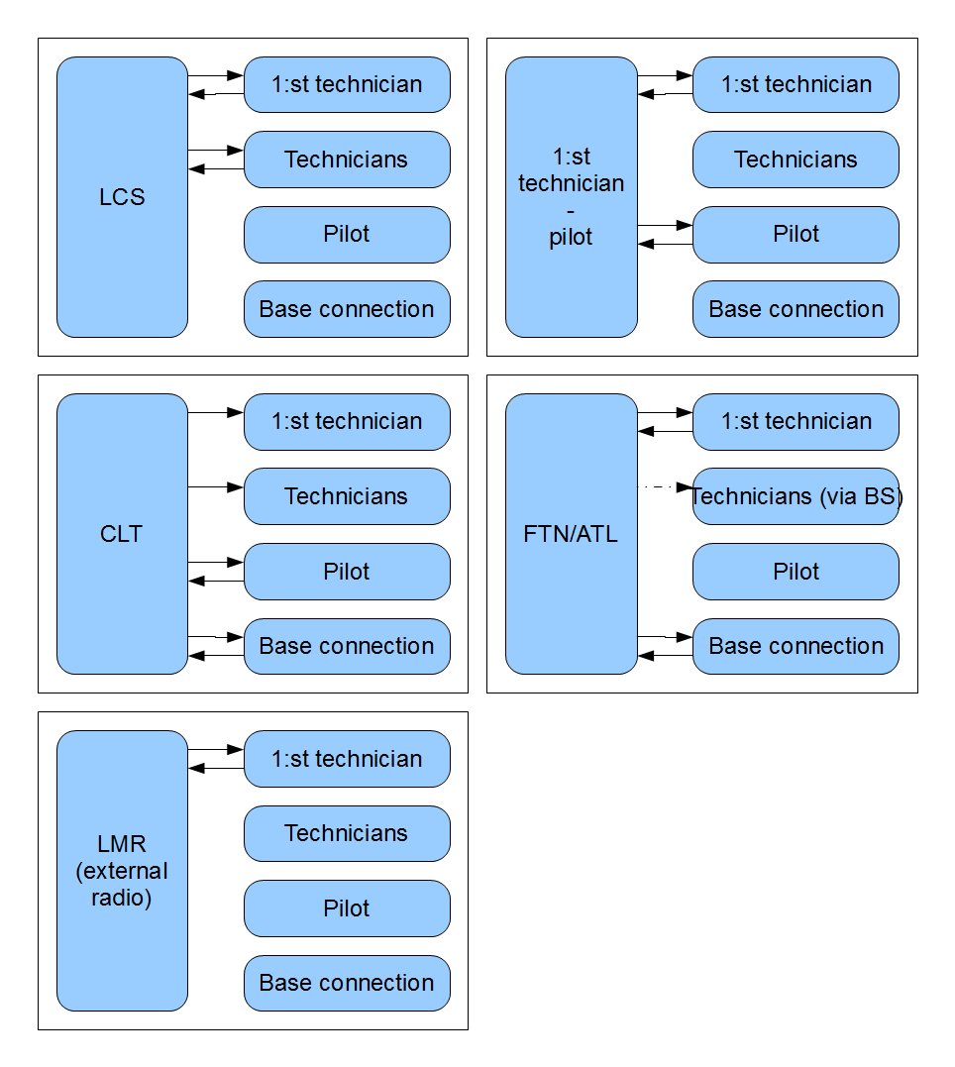

Figure 1. Audio path configurations for different connection types. LCS is the local communication taking place between technicians. External communications are CLT, FTN and LMR. 1st technician have the possibility to communicate with the pilot.

### Personal transceiver

A signal flow chart for the PT is shown in Figure 2. The PT is carried by either a technician or the 1st technician. The difference between the two users is the configuration of channels in the mixer. The 1st technician is allowed to listen to more channels than the other technicians. The channel mixer configuration is given in Table 6. The microphone signal coming from the headset is converted to a digital signal with and analog to digital converter (ADC) and processed by noise reduction and AGC. A VAD is used to mute the channel when no active speech is detected. A side tone with the users own microphone is added to the headset output when the VAD/PPT opens the channel.

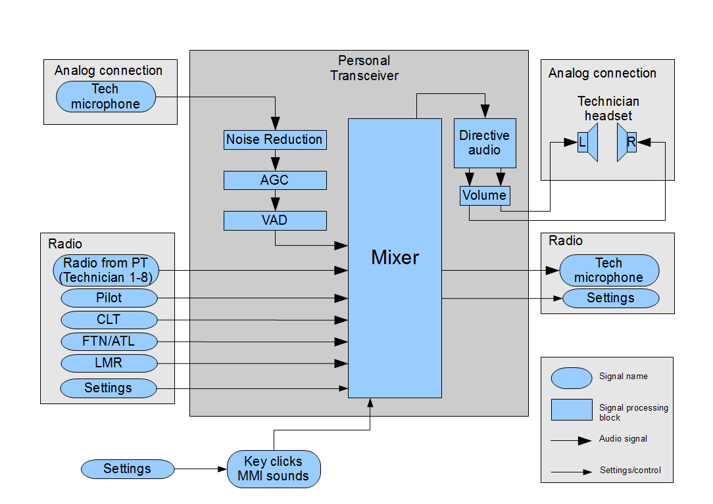

Figure 2. Signal flowchart in PT. Input radio signals are combined in the mixer and the directive audio processing block and then sent to the headset speakers. The microphone signal is processed with noise reduction and AGC and sent to radio output and side tone signal for use in headset. A VAD is used for muting the channel. The VAD could be override by a push to talk button.

### Base station

The base station is a unit for communication outside the local radio traffic. The line input signals and the necessary signal processing blocks are shown in Figure 3. The CLT is connected either with a 2-wire or 4-wire interface. When connected to a 2-wire interface a LEC is necessary. The FTN line is also connected to a 2-wire interface, also requiring a LEC for that channel. External radio (LMR) establishes communication to the 1st technician with headset connected to the PT.

The microphone input for headsets connected to the BS is shown under the Analog connection inputs. The pilot input comes either from a connection to the aircraft with an analogue 4-wire interface or by connecting the pilot headset to an LCS-jack on the BS. A technician is also allowed to connect to an LCS-jack. The LCS jack signals are processed with noise reduction and AGC. A VAD is used on both channels. It is possible to override the VAD by a push to talk switch located on the BS. This push to talk opens both the technician and the pilot microphone channel. The processed microphone signals are sent to multiple outputs depending on the current system configuration. For all possible mixer channel configurations on BS see Table 7.

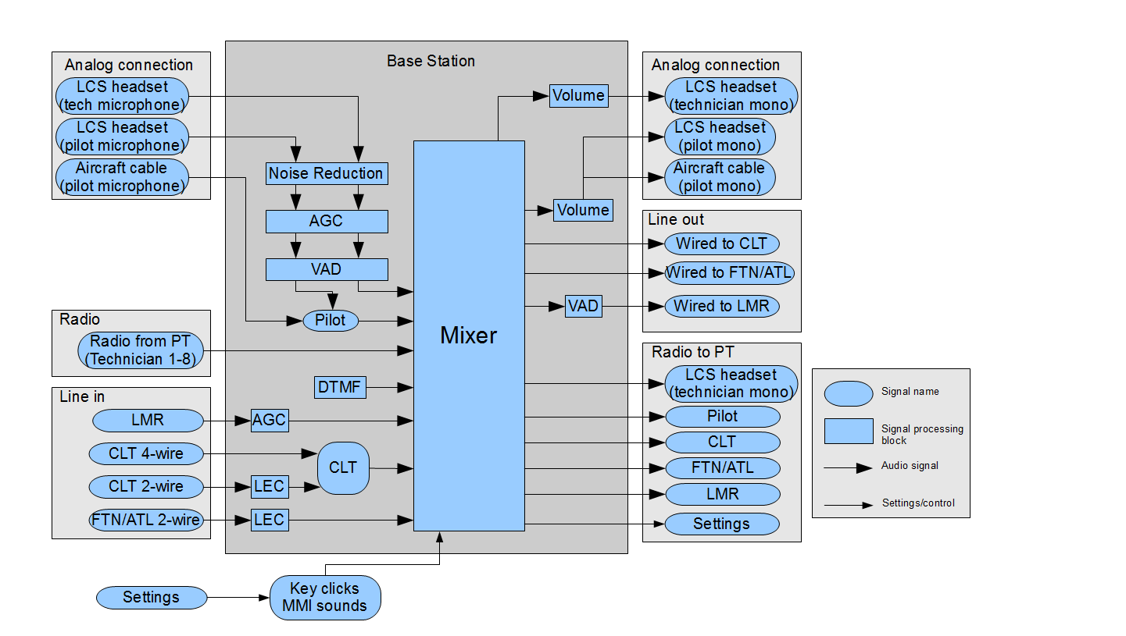

Figure 3. Signal flowchart of inputs and outputs to the BS. There is both a 2-wire and a 4-wire CLT connection. A LEC is used when a 2-wire connection is made. FTN connection is made via a 2-wire analogue interface. Audio from LMR is processed by an AGC and the audio going out to LMR channel is opened/muted by a VAD. The microphone signals is processed with noise reduction and AGC and sent to multiple outputs and side tone signal for use in headset. The pilot can be connected direct to BS with the headset or via the aircraft.

### Communication adapter

The communication adapter can be seen as a simplified version of the BS. Figure 4 shows the input signals and signal processing applied to these channels. Major signal processing blocks are noise reduction, AGC and VAD on the two headset input channels. The output signal processing consists of one signal mixer and directive audio block on the technician headset output channel and one signal mixer for the pilot headset channel. For the possible mixer channel configurations on CA see Table 8.

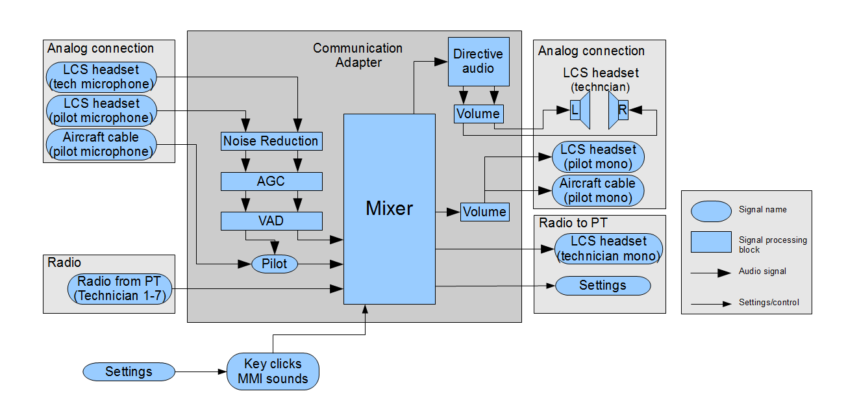

Figure 4. Input and output signals to the communication adapter. The pilot can be connected to CA with the headset or via the aircraft. A technician could connect the headset direct to the CA. Up to 7 PT can be connected via radio, these microphone signals have already been processed and are direct routed to output.

## Audio signal buffers

The same interface function (true_voice) is used for audio processing in PT, BS and CA. This is possible since TrueVoice takes pointers to all possible audio signals as input. If a signal is not present on that system unit, the corresponding audio buffer pointer is not used by TrueVoice, and can be set to any value (preferably NULL).

The list of possible channels for the received signals is shown in Table 9, the list for microphone channels in Table 10, the list for transmitted signals is shown in Table 11 and the possible speaker signals are given in Table 12.

The sample rate of all audio signals is 8 kHz and the audio block size is 4ms (equals 32 samples).

Table 9. Struct names, channel source and availability on the components in LUF for receive channels.

| **Struct name** | **Description** | **Channel source** | **Used on PT** | **Used on BS** | **Used on CA** |
| --- | --- | --- | --- | --- | --- |
| *struct tvRxChannels_t* | Typedef declaration |  |  |  |  |
| *psTech1 | Technician PT | Radio interface | Yes | Yes | Yes |
| *psTech2 | Technician PT | Radio interface | Yes | Yes | Yes |
| *psTech3 | Technician PT | Radio interface | Yes | Yes | Yes |
| *psTech4 | Technician PT | Radio interface | Yes | Yes | Yes |
| *psTech5 | Technician PT | Radio interface | Yes | Yes | Yes |
| *psTech6 | Technician PT | Radio interface | Yes | Yes | Yes |
| *psTech7 | Technician PT | Radio interface | Yes | Yes | Yes |
| *psTech8 | Technician PT | Radio interface | Yes | Yes | Yes |
| *psMmiSounds | Audio effects from man-machine interface | ARM/Flash? | Yes | Yes | Yes |
| *psLmr | Land mobile radio | Radio interface | Yes | Yes | No |
| *psFtn | 2-wire analog telephone line from defense telephone network on BS. Processed FTN signal with line echo removed on PT. | Radio interface (PT)/Line interface(BS) | Yes | Yes | No |
| *psPilot | Pilot signal. This is available as microphone signals on BS and CA. | Radio interface | Yes | No | No |
| *psClt | Line for take of command. | Radio interface | Yes | No | No |
| *psClt4wire | 4-wire communication line for take of command. | Line interface | No | Yes | No |
| *psClt2wire | 2-wire communication line for take of command. | Line interface | No | Yes | No |

Table 10. Struct names, channel source and availability on the components in LUF for microphone channels.

| **Struct name** | **Description** | **Channel source** | **Used on PT** | **Used on BS** | **Used on CA** |
| --- | --- | --- | --- | --- | --- |
| *struct tvMicChannels_t* | Typedef declaration |  |  |  |  |
| *psMicNoise | Microphone placed on unit (PT, BS, CA) used for monitoring of noise level | ADC | Yes | Yes | Yes |
| *psTechHeadset | Microphone on technician headset | ADC | Yes | Yes | Yes |
| *psPilotHeadset | Microphone on pilot headset when connected to headset jack on BS or CA | ADC | No | Yes | Yes |
| *psPilotCable | Microphone on pilot headset when connected via aircraft cable | ADC | No | Yes | Yes |

Table 11. Struct names, channel destination and availability on the components in LUF for transmit channels.

| **Struct name** | **Description** | **Channel destination** | **Used on PT** | **Used on BS** | **Used on CA** |
| --- | --- | --- | --- | --- | --- |
| *struct tvTxChannels_t* | Typedef declaration |  |  |  |  |
| *psTechToRadio | Processed technician headset | Radio interface | Yes | Yes | Yes |
| *psPilotToRadio | Processed microphone signal from pilot. The microphone signal is taken either from the aircraft cable or the headset jack on the BS or CA | Radio interface | No | Yes | No |
| *psFtnToLine | Output to FTN line | Line interface | No | Yes | No |
| *psCltToLine | Output to CLT line | Line interface | No | Yes | No |
| *psLmrToLine | Output to LMR line | Radio interface | No | Yes | No |
| *psFtnToRadio | Processed FTN line with echo removed | Radio interface | No | Yes | No |
| *psCltToRadio | Processed CLT line with echo removed | Radio interface | No | Yes | No |
| *psLmrToRadio | Processed LMR line with VAD and AGC | Radio interface | No | Yes | No |

Table 12. Struct names, channel destination and availability on the components in LUF for speaker channels.

| **Struct name** | **Description** | **Channel destination** | **Used on PT** | **Used on BS** | **Used on CA** |
| --- | --- | --- | --- | --- | --- |
| *struct tvSpeakerChannels_t* | Typedef declaration |  |  |  |  |
| *psTechLeft | Left channel technician headset | DAC | Yes | No | Yes |
| *psTechRight | Right channel technician headset | DAC | Yes | No | Yes |
| *psTechMono | Mono channel technician headset | DAC | No | Yes | No |
| *psPilotMono | Mono channel pilot headset | DAC | No | Yes | Yes |

## Interface functions

A complete list of interface functions for TrueVoice is given in Table 16.

During initialization of TrueVoice the configuration for the specific platform is made. The possible configurations are given in Table 13. An enumerated list of receive channels is useful for the interface functions and is provided in Table 14. An enumerated list of signal processing modules is also useful for the interface functions and is listed in Table 15. The list shows the modules that are possible to enable/disable. The default configuration in TrueVoice is that all signal processing modules is enabled.

Table 13. Enumeration for configuration modes of TrueVoice.

|  |  |
| --- | --- |
| **Enumeration name** | **Description** |
| *enum tv_config_t* | Typedef declaration |
| TV_CONFIG_PT | TrueVoice configuration for PT |
| TV_CONFIG_BS | TrueVoice configuration for BS |
| TV_CONFIG_CA | TrueVoice configuration for CA |
| NUM_TV_CONFIGS | Total number of configurations |

Table 14. Enumeration of receive channels.

| **Enumeration name** | **Description** |
| --- | --- |
| *enum rx_channel_enum_t* | Typedef declaration |
| RX_CH_TECH_1 | Technician PT |
| RX_CH_TECH_2 | Technician PT |
| RX_CH_TECH_3 | Technician PT |
| RX_CH_TECH_4 | Technician PT |
| RX_CH_TECH_5 | Technician PT |
| RX_CH_TECH_6 | Technician PT |
| RX_CH_TECH_7 | Technician PT |
| RX_CH_TECH_8 | Technician PT |
| RX_CH_MMI_SOUNDS | Audio effects from man-machine interface |
| RX_CH_LMR | Land mobile radio |
| RX_CH_FTN | 2-wire analog telephone line from defense telephone network. |
| RX_CH_PILOT | Pilot signal. This is available as microphone signals on BS and CA. |
| RX_CH_CLT | Line for take of command. |
| NUM_RX_CHANNELS | Total number of receive channels. |

Table 15. Enumeration of signal processing modules that is possible to enable/disable.

|  |  |
| --- | --- |
| **Enumeration name** | **Description** |
| *enum eTvModules_t* | Typedef declaration |
| AGC | Automatic gain control |
| DIRECTIVE_AUDIO | Directive audio (only on PT and CA) |
| LEC | Line echo cancellation |
| LS_LIMITER | Limiter on loudspeaker |
| NOISE_REDUCTION | Noise reduction |

Table 16. Function prototypes for TrueVoice.

| **Name** | **Description** | **Parameters** | **Return** |
| --- | --- | --- | --- |
| void true_voice_init(tv_config_t) | Initialize TrueVoice. Called one time at startup of system. | Configuration mode according to Table 13. | None |
| void true_voice(tvRxChannels_t, tvMicChannels_t, tvTxChannels_t, tvSpeakerChannels_t) | Audio processing including noise reduction, voice activity detection, directive hearing. Called continuously as new audio input samples are available and new (processed) output is required. | Pointers to receive signal buffers | None |
| Pointers to microphone signal buffers |
| Pointers to transmit signal buffers |
| Pointers to speaker signal buffers |
| short true_voice_clt_mode(short) | Provide TrueVoice with information on which CLT connection that is used, i.e. 2-wire or 4-wire. NOTE: This setting only affects BS. | Pilot configuration  0 4-wire (default)  1 2-wire  -1 Read current setting | Current pilot configuration |
| short true_voice_mixer_active_channels(rx_channel_enum_t, short) | Provide TrueVoice with information on which channels that should be used in the speaker channel mixer. If e.g. communication with the pilot is started that channel has got to be opened in the mixer. Default configuration is given in Table 6, Table 7 and Table 8. | Receive channel enumeration according to Table 14. | Current setting for the specified channel |
| On/off state for the specified channel  0 Channel closed  1 Channel open  -1 Read current setting |
| short true_voice_mixer_mode(short) | Provide TrueVoice with information on how the directive audio should be configured, i.e. the stereo direction of the input channels. NOTE: This setting only affects PT. | Mixer configuration  0 Regular technician (default)  1 1st technician  -1 Read current setting | Current mixer configuration |
| short true_voice_mixer_1st_tech_channel(rx_channel_enum_t) | Specify which of the rx channels that the 1st technician uses. This is for the mixer so that the correct direction of the 1st tech is made. | Channel number n according to the RX_CH_TECH_n channels specified in Table 14, the default channel is RX_CH_TECH_1. To only read current configuration use NUM_RX_CHANNELS. | Current 1st technician channel |
| short true_voice_module_enable( eTvModules_t, short) | Enables/disables signal processing modules in true voice. The default setting is that all modules are enabled. | Modules according to Table 15 | Current setting for the specified module |
| On/off state for the specified module  0 Module disabled  1 Module enabled  -1 Read current setting |
| short true_voice_pilot_mode(short) | Provide TrueVoice with information on which pilot connection that is used, i.e. Pilot cable from aircraft or headset jack. NOTE: This setting only affects CA and BS. | Pilot configuration  0 Pilot from aircraft cable (default)  1 Pilot from headset jack  -1 Read current setting | Current pilot configuration |
| short true_voice_push_to_talk(short) | Override of VAD via push to talk button. | VAD override setting.  0 (default) normal VAD operation mode.  1 Override VAD and open channel  -1 Read current setting | Current VAD override setting. |
| short true_voice_vad_sensitivity(short, short) | Adjust sensitivity of VAD. | Channel number for adjusting  1 Technician headset  2 Pilot headset (only BS and CA)  3 LMR (only BS) | Current VAD sensitivity setting |
| Sensitivity level at which voice is detected  0 Weak voice required  1 Semi-weak voice required  2 Normal mode (default)  3 Semi-loud voice required  4 Loud voice required  -1 Read current setting |
| short true_voice_vad_status(short) | Read current VAD status. | Channel number for status check  1 Technician headset  2 Pilot headset (only BS and CA)  3 LMR (only BS) | Current VAD status  0 Channel closed  1 Channel open |
| short true_voice_volume_speaker(short, short) | Set volume damping level. | Channel number for adjusting  1 Technician headset  2 Pilot headset (only BS and CA) | Current volume setting for selected channel number |
| Volume damping setting  0 for 0 dB damping  1 for 1 dB damping  …  29 for 29 dB damping  30 for 30 dB damping  -1 to read current setting |
| void true_voice_get_version_info(short*, short*, short*, char[12], char[9]) | Read version information for TrueVoice. Useful during debug. | Major version number | None |
| Minor version number |
| Build version number |
| Build date |
| Build time |
| void true_voice_dtmf_clear_queue() | Remove all characters currently in queue. |  | None |
| void true_voice_dtmf_queue(char) | Sets characters from DTMF in queue before sending. | Character to set in DTMF queue | None |
| void true_voice_dtmf_remove_last_added() | Remove the character that was last added to the queue. |  | None |
| void true_voice_dtmf_send_queue() | Send all characters currently in queue. |  | None |
| void true_voice_dtmf_settings(short, short) | Specify the tone and pause duration for DTMF signals. | Tone duration in ms | None |
| Pause duration in ms |

### Initialization

Initialization is made with the true_voice_init() function by supplying the platform (PT, BS or CA) as parameter. This configures TrueVoice for the default setting for that configuration.

### Configuration of signal mixer

The signal mixer configuration possibilities are described here.

#### Open/closed mixer channels

The default setting for the signal mixer is that all open channels specified in Table 6, Table 7 and Table 8 are used. If some of the channels are known to not being used, e.g. no communication takes place on LMR, FTN or CTL it is possible to disable the specific channel in the mixer. It is recommended to disable unused channels to achieve optimal sound quality, both background noise level and sound artifacts are more likely to occur if an empty channel is left open. The configuration of open channels is made with the interface function true_voice_mixer_active_channels().

#### Selection of 1st technician mode

The mixer configuration differs for the 1st technician and the other technicians. The 1st technician has the option to listen to more channels than the regular technician. Also, the directivity of the channels differs between the two types of users. The default configuration is made for the regular technician but it is possible to switch to a 1st technician mode with the interface function true_voice_mixer_mode().

#### Specification of 1st technician radio channel number

The direction of the 1st technician in the directive audio module is specified. However it is necessary to specify which radio channel that contain the 1st technician audio signal. The default setting is that the technician channel 1 is used for the 1st technician. It is possible to have the 1st technician use any channel. The configuration of the 1st technician channel is made with the interface function true_voice_mixer_1st_tech_channel().

#### Selection of CLT 2- or 4-wire

CLT connection can be made with either a 2- or 4-wire connection. To process the signal with correct modules TrueVoice has to know which connection that is used. This is selected manually by the interface function true_voice_clt_mode().

#### Selection of pilot connection

The pilot connection can be made with either an aircraft cable or a headset connected directly to the BS or the CA. To know which signal to send to radio or technician headset a selection of which connection that is used need to be made. This is done with the interface function true_voice_pilot_mode().

### Specification of active signal processing modules

It is possible to disable some of the signal processing modules. The interface function true_voice_module_enable() enables/disables modules. All modules are by default enabled.

### Configuration of VAD

The configuration possibilities of the VAD are presented here.

#### VAD sensitivity

The VAD sensitivity can be set to five different sensitivity modes for all individual VAD modules.

#### Push-to-talk

It is possible to override any individual VAD and open the channel. This is used for the implementation of a push-to-talk button.

### Speaker volume adjustment

It is possible to change the headset speaker volume and within a range of 30 dB where all volume steps are separated by 1 dB. The default volume setting is the loudest (0 dB damping). The volume setting does not affect MMI sounds such as button push notifications. The MMI signals are kept at a constant volume setting.

### DTMF generation

It is possible to change the length of the DTMF tone and the pause duration. This is made with the interface function true_voice_dtmf_settings(). The default setting is a duration of 80ms for the DTMF tone and 80ms for the pause. When using DTMF the characters are queued to await the possibility to be sent. The characters are queued using the function true_voice_dtmf_queue(). This queue can later be sent with the function true_voice_dtmf_send_queue(). It is also possible to clear the entire queue, this is made with the function true_voice_dtmf_clear_queue(). The character that was last added to the queue can also be removed using the function true_voice_dtmf_remove_last_added().